

Hand Held Terminal G-8:

Overview:
APPLICATIONS  THAT  eMPOWER | 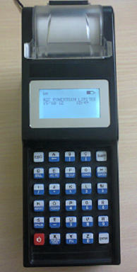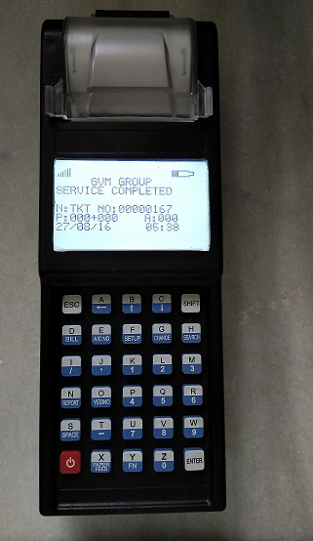
 | Display :128 x64 Display :128 x6 View Area (W x H):50x25 mm View Area (W x H):70x40 mm

G-8 a mobile handheld data capture, billing and Collection terminal to process and transmit information to host computers in real time. The simple user friendly design allows you to operate with easy and light weight and handy. Inbuilt thermal graphic printer high clarity graphic LCD display and keypad with good user interface. The Stored data can be uploaded to a PC via USB/RS-232 serial interface and GSM/GPRS wireless interface. The Device transfers billing data on GPRS to application Server at central Data center in both PUSH &PULL manners without any manual intervention. The PC software will be used for restoring all required MIS reports in the System.
32 bit Processor

Thermal Management Printer
GSM/RS232/USB
Micro SD Card
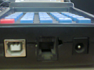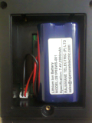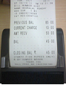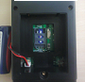

USB & RS232 Ports Battery Compartment Bill Printing SIM card Access

Features:  Built-in 2inch thermal printer  Prints Barcode, Logo ,Image  Supports Four Different programmable Fonts  30 Keys Elastomeric designed keypad  Large bright graphical display  Self-diagnostic features  Compact and Comprehensive  Fast-Intelligent-Versatile-Affordable  Lithium-Ion rechargeable battery  User programmable  Easy paper loader  Fast-Intelligent-Versatile-Affordable | Application Areas:  TIMS in Road transport  Parking Management  Retail outlet  Police e- Challan  Utility Meter Reading & Billing  Tax Collection  Field Data Collection  LIC payment collection  Receipt Printing  Micro Finance  Toll gate management.  Ticketing

Supporting Utilities:
- SDK with APIs

Specifications:
Processor | 32 bit RISC @ 80/120 MHz
Display | 128 x 64 pixel graphic FSTN LCD with backlight
Memory | 512 KB Flash memory, 128 KB SRAM, 4MB data flash,
Printer | 2-inch Thermal Graphic Printer
Interface/Connector | a).RS-232 (RJ11 Connector for console / Serial port)  b).USB Device (Type B)  c).Micro SD Card holder for extendable up to 2GB memory
Optional | Custom Keypad a) Customized Software  b) HF RFID Transceiver  c) Wi-Fi /Blue tooth  d) IRDA  e) GSM/GPRS  f) GPS  g).1D/2D Barcode Scanner.
Power Adaptor | AC Input 100-240V ±30 %, 50Hz ±10%, DC output 10V, 3Amp
Battery | Rechargeable Li-ion 7.4V/2.2Ah
Enclosure | ABS+PC
Temperature | Operating : 0degree C to 55degree C
Humidity | 95% RH non condensing
EMI/EMC and Type tests | Comply As per IEC /IS standards
Dimensions in mm | 245 x 55 x 80 ( L x w x H)
Weight | 400 grams

System Concept and Architecture Diagram:


FIRE WALL
WEB SERVER
DATABASE
SERVER
Circle wise APPLICATION
SERVERS
HANDHELD
DEVICE
USER

GVM Electronic Systems.

Registered office:  502, Sri sai land mark, Block-A  Street No-8,Habsiguda  Hyderabad - 500007,  Telangana (INDIA).  Website : www.gvmgroup.co.in |  | R&D Center:  1-7-9/3, Level 1 Harihara Estates,  Opp ISI, Street No. 8,Habsiguda,  Hyderabad - 500007  Telangana (INDIA)  Tel : 040 – 40073218.

